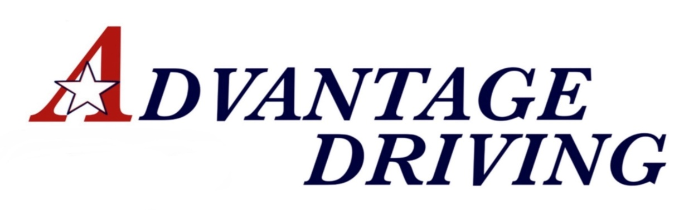
This Photo by Unknown Author is licensed under CC BY-SACC
COVID-19 POLICY UPDATE

Welcome to Advantage Driving LLC. We are open and fully functional during this pandemic. In an effort to keep EVERYONE safe, please take a few minutes to review our updated policies and procedures regarding COVID safety measures.
- In-Class instruction attendance levels are kept at a reduced number to allow for distancing of students.
- Masks are required at all times in the building as well as in the car for instruction, except for when the students are eating lunch in the classroom.
Masks MUST be worn as designed (covering the entire mouth area as well as over the nose).
- All surfaces in the classroom as well as the car are sanitized before and after each instruction
- Hand sanitizer is placed all over the office, as well as the in each car.
- Prior to In-car instruction, the instructor will contact the student the day before their scheduled lesson to ensure that neither the student nor anyone in their family have been exposed to COVID in the past 14 days.
- If a student/family have been exposed, the lesson MUST be rescheduled.
- Prior to In-car instruction, the instructor may take a student’s temperature using a no-touch thermometer to ensure they are fever-free. If a student has a fever of 100.4 or above, the lesson will be rescheduled with a minimum of a 14-day waiting period.
Please call us with any questions or concerns you may have. We can be reached at (803) 798-8400.
We thank you for your business and looking forward to serving you.
Susan Piercey
Owner, Advantage Driving LLC

